Aug 12, 2009 ML-AG113

Ms. A. Hebert, Chief
Mobile Source Operations Division
Air Resources Board
9480 Telstar Avenue, Suite 4
El Monte, CA 91731

Dear Ms. Hebert:

Subject: General Motors Company Functional Test Plan for the 2010 Model Year

Please find attached the General Motors Company Functional Test Plan for the 2010 model year. This is being submitted for approval in accordance with the requirements of the California Assembly-Line Test Procedures. For the 2010 model year, the determination of compliance with regard to on-board or off-board testing of OBD II P-codes has been made based on engineering data and/or engineering judgment. Except for the serial data link, which must be present to run our functional test, all applicable emissions systems and components are covered in the attached P-code tables.

The attached document contains, in part, information which constitutes trade secrets, commercial data or confidential, proprietary information which is not normally disclosed to third parties because they could gain an unfair competitive advantage from it. Accordingly, General Motors believes the attached document contains information which constitutes trade secrets and commercial information within the meaning of Section 6254.7 of the California Public Records Act and is entitled to confidential treatment pursuant to the California Public Records Act (Government Code Section 6250 et seq.) and Sections 91000-91022 of Title 17 of the California Code of Regulations. In the event that CARB does not agree with our position regarding confidential treatment of the subject information, we request the opportunity to discuss the matter with you or the CARB General Counsel before any decision is made regarding its release.

If you have any questions concerning this matter, please contact Mr. Antonio M. Martino at
818-997-5517 or Jim York 248-685-5758.

Sincerely,

Randall C. Harvey, Group Manager
Compliance & Certification

RCH/JMY
Attachments
c: A. Martino
Functional Test Plan

Emission-Related Components and/or Systems*

The purpose of the functional test plan is to ensure that the emission control system components of California vehicles are assembled correctly and functioning properly.

Dynamic Vehicle Test (DVT)

Emission-related systems controlled by the engine control module (ECM), transmission control module (TCM), powertrain control module (PCM), or vehicle control module (VCM), as applicable, are functionally tested by the dynamic vehicle test (DVT). The DVT is conducted with the vehicle on a roll test machine. There are multiple DVT test sites at each vehicle assembly plant. Each DVT test site has a test computer. Each vehicle's ECM/TCM/PCM/VCM incorporates a feature which monitors ECM/TCM/PCM/VCM activity and produces data showing the status of all sensors and controls that are monitored. The data are fed to the external test computer by means of the vehicle's data link connector (DLC, also known as ALDL) to the test computer. The test computer prompts the test operator by means of a display unit through all required test modes. Test algorithms and parameters which control running conditions within specified ranges are stored in the test system. When monitored sensor or control outputs in the data do not correspond to predetermined response parameters, a fault is indicated.

Successful communication of data to the DVT verifies that the on-board diagnostic system and serial communication link is functioning. The DVT interrogates the vehicle's ECM/TCM/PCM/VCM for diagnostic trouble codes. Any diagnostic trouble codes identified during the DVT by the on-board diagnostic (OBD) system, and any "malfunctions" or "faults" identified by the off-board DVT checks, are recorded. All vehicles must pass DVT prior to shipment. A description of the functional test process is shown in Figure 1. The DVT drive cycle / test sequence is shown in Figure 2.

The following systems, components and functions are verified by an off-board computer during DVT.

Air-Fuel Control/Fuel Injectors
The DVT monitors the oxygen sensor and fuel trim values to verify that the closed loop system is functional and air-fuel ratio is in control. If the exhaust is lean or rich to a level that is outside the determined parameters, the DVT will set a "fault." In this way, significant lean conditions such as vacuum leaks and rich conditions such as high fuel pressure or rich injectors are detected. Likewise, if the fuel trim correction is outside the parameters the DVT will set a fault.

Throttle System (Throttle Position Sensor and Pedal Position Sensor)
Sensor voltages are measured and compared to acceptable parameters and must exhibit a large enough delta during the DVT.
____________________________________________________________________
* Not all components/systems are applicable for all products. Please see certification documentation.
Engine Coolant Temperature Sensor (ECT Sensor)
The DVT verifies that the ECT sensor output is within acceptable parameters and that the engine can reach and maintain a warm engine condition.

Oxygen Sensors
The DVT verifies that the pre-catalyst oxygen sensor(s) are operating and transitioning between rich and lean states. The DVT verifies that the post-catalyst oxygen sensor(s) are operating within acceptable parameters.

Camshaft Position / Sensor and Crankshaft Position Sensor
Camshaft position and/or crankshaft position are measured and compared to acceptable parameters.

Idle Air Control Valve (IAC Valve)
The DVT verifies that the ECM/PCM/VCM can control to the desired idle speed within acceptable parameters.

ECM/TCM/PCM/VCM System
Successful communication with the controllers by the DVT verifies that the controllers are functioning.

Mass Air Flow Sensor (MAF Sensor)
Sensor voltage is measured and compared to acceptable parameters and must exhibit a large enough delta during the DVT.

Manifold Absolute Pressure Sensor (MAP Sensor)
Sensor voltage is measured and compared to acceptable parameters and must exhibit a large enough delta during the DVT.

EGR System Test
The EGR valve is opened and a corresponding change in manifold air pressure (MAP) and/or EGR pintle position sensor feedback must occur.

Intake Air Temperature Sensor (IAT Sensor)
The DVT verifies that the IAT sensor output is within acceptable parameters.

Transmission Fluid Pressure Sensor/Switch Assembly/Range Sensor Switch
The DVT requires the pressure sensing manifold (PSM) to indicate every position.

Transmission Shift Solenoids/Stepper Motors
The DVT verifies that the transmission shifts manually and automatically.
Torque Converter Clutch (TCC) System
The DVT verifies the TCC functionality based on reported feedback from the vehicle controller.

Transmission Temperature Sensor
The DVT verifies that the transmission temperature sensor output is within acceptable parameters.

Transmission System
The DVT verifies that the transmission shifts into all gears by monitoring the transmission gear ratio.

Vehicle Speed Sensor (VSS)
The DVT verifies that the ECM/TCM/PCM/VCM vehicle speed input is within acceptable parameters as compared to the speed of the roll test machine.

Clutch Switch
The DVT verifies that the clutch switch status has changed in response to the operator depressing the clutch.

Brake Switch
The DVT verifies that the brake switch status has changed in response to the operator depressing the brake.

Four Wheel Drive Low Circuit Performance
The DVT verifies switch functionality by comparing switch position to vehicle operation.

Electric Cooling Fan(s)
The fan(s) is turned on and the system voltage is monitored for a corresponding drop.

AIR System
The DVT exercises the AIR system while the oxygen sensor(s) are monitored for an appropriate response.

Engine Operation
The DVT determines normal engine behavior using data from the engine coolant temperature sensor, manifold absolute pressure sensor, idle air control valve, ignition, and mass air flow sensor to determine if they are within acceptable parameters. Based on all of these inputs, a number of functional checks are conducted, including ignition timing, misfire, electronic spark timing, and fuel injectors.

Other Functional Tests

Some emission-related systems operate independently and are not monitored by the DVT. Various stand-alone tests and inspection operations are used to verify integrity of the systems and components. Other emission-related components or systems do not lend themselves to a functional test in the assembly environment. In such cases, functional testing/verification is required of the supplier.

Evaporative Emission/ORVR System
The suppliers of all enhanced evaporative emissions/ORVR system components, using statistically valid sampling, assure all parts are leak free before they ship (vendor qualified). Visual inspection during assembly is performed to identify wrong routings, pinched or loose connections and disconnections of mechanical, vacuum and electrical items.

Catalytic Converter
The content of catalytic converters is assured by the supplier before shipment. The composition of the catalyst material is verified on a lot basis. In the converter assembly process, converters are 100% tested for freedom from leaks.

Emission-Related Hoses, Tubing, Clamps, Belts, Fittings, Wiring, Connectors, Sensors and Switches Interconnecting in emission-related systems is functionally verified by respective functional tests on individual systems. In most cases, disconnects or blocked passages inhibit system function and result in "fault" detection in the functional test. The assembly integrity of clamps, hoses, tubing, and belts is subjective and depends on individual assembly operations. Visual inspection during assembly is performed to identify wrong routings, pinched or loose connections and disconnections of mechanical, vacuum, ignition control and electrical items. Various sensors, switches and connectors are either checked independently, vendor qualified, and/or DVT verified.

Positive Crankcase Ventilation System The function of the PCV valve is assured by the supplier before shipment. Visual inspection of the PCV system is conducted during manufacture. The general integrity of the PCV system, such as gross leaks, would be detected during the DVT process.

Engine Knock Sensor (KS)
Visual inspection during assembly will verify that the knock sensor is properly connected.

Thermostat
Each thermostat is functionally checked by the supplier before shipment.
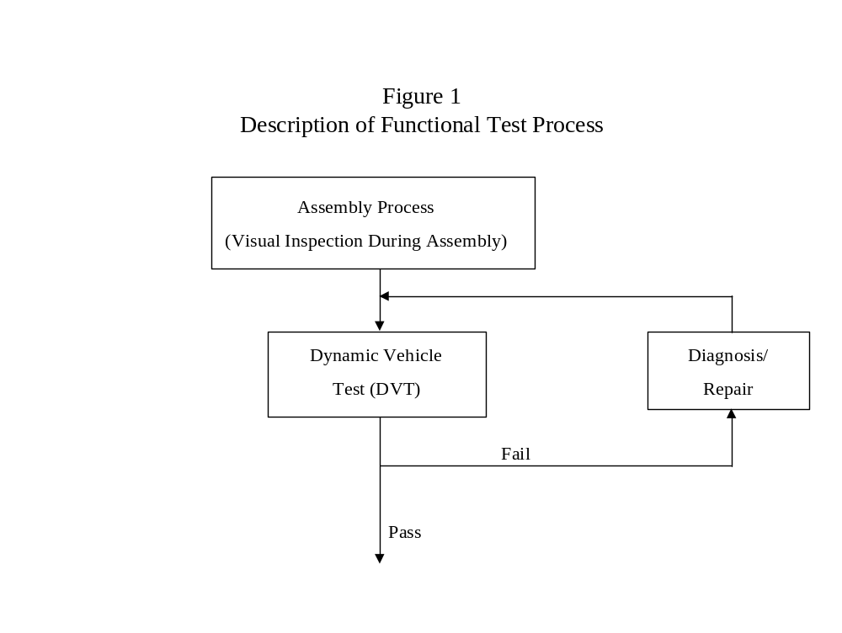
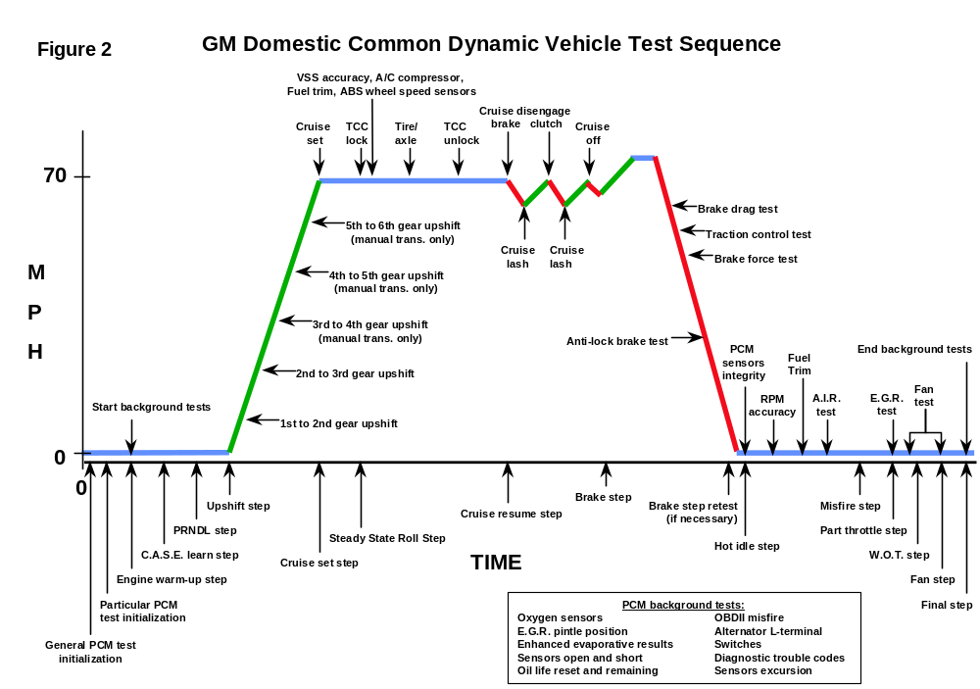

Component/System Monitored | Fault Code(s) | ITP OBD II Checks  Carried Out By |  | Comments
INPUT COMPONENTS |  | OBD II System | Offboard DVT
Mass Air Flow (MAF) Sensor/System | P0100, P0101, P0102, P0103, P2281 | A
Manifold Absolute Pressure (MAP) Sensor/System | P006D, P023D, P0069, P0072, P0073, P0074, P009A, P0106, P0107, P0108, P0109, P1106, P1107, P1108, P1451, P2227, P2228, P2229 | A
Air Temperature (IAT) Sensor | P0096, P0097, P0098, P0111, P0112, P0113, P0114, P0640, P1101, P1110, P154A, P154B, P154C, P154D, P2070 | A
Engine Coolant /Oil Temperature (ECT) Sensor | P0116, P0117, P0118, P0119, P0125, P0126, P1258, P0A01, P0A02, P0A03, P0A05, P0A06, | A
Engine Coolant /Oil Temperature (ECT) Sensor | P011A, P0196, P0197, P0198, P050C, P2184, P2185 | B
Throttle Position (TP) Sensor/System | P0068, P0120, P0121, P0122, P0123, P02E0, P02E7, P02E8, P02E9, P0220, P0221, P0222, P0223, P2107, P2119, P2135, P2176, | A
Oxygen Sensor B1S1 | P0030, P0031, P0032, P0040, P0053, P0130, P0131, P0132, P0133, P0134, P0135, P2195, P2196, P2231, P2237, P2238, P2239, P2243, P2251, P2297, P2626, P2A00 | A
Oxygen Sensor B1S1 | P0133, P1132, P1133, P1134, P1135, P1136, | B | C, E, F

Component/System Monitored | Fault Code(s) | ITP OBD II Checks  Carried Out By |  | Comments
INPUT COMPONENTS |  | OBD II System | Offboard DVT
Oxygen Sensor B1S2 | P0036, P0037, P0038, P0054, P0136, P0137, P0138, P0139, P013A, P013B, P013E, P013F, P0140, P0141, P2096, P2097, P2232, P2270, P2271, P2A01 | A
Oxygen Sensor B1S2 | P0137, P1137, P1131, P1141, P1142 | B | C, E, F
Oxygen Sensor B2S1 | P0050, P0051, P0052, P0059, P0151, P0152, P0153, P0154, P0155 | A
Oxygen Sensor B2S1 | P0153, P1153, P2234, P2A03 | B | C, E, F
Oxygen Sensor B2S2 | P0056, P0057, P0058, P0060, P013C, P013D, P014A, P014B, P0158, P0160, P0161, P2098, P2099, P2235, P2272, P2273, P2A04 | A
Oxygen Sensor B2S2 | P0157 | B | C
Electronic Throttle Control System (ETC) | P0638, P1125, P1516, P1523, P1530, P1551, P1791, P2100, P2101, P2105, P2108, P2119, P2120, P2121, P2122, P2123, P2125, P2126, P2127, P2128, P2138, P2776 | A
Knock Sensor (KS)
Knock Sensor (KS) | P0324, P0325, P0326, P0327, P0328 P0330, P0331, P0332, P0333 | B |  | Visual inspection for positive connection.  Supplier functionally checks sensor.
Crankshaft Position (CKP) Sensor | P0016, P0017, P0018, P0315, P0335, P0336, P0337, P0338, P0339, P0385 | A
Crankshaft Position (CKP) Sensor | P0386, P1344 | B | F

Component/System Monitored |  | Fault Code(s) |  |  | ITP OBD II Checks  Carried Out By |  | Comments
INPUT COMPONENTS |  |  |  |  | OBD II System | Offboard DVT
Camshaft Position (CMP) / Sensor |  | P000A, P000B, P000C, P000D, P0010, P0011, P0013, P0014, P0016, P0017, P0020, P0021, P0023, P0024, P0340, P0341, P0342, P0343, P0345, P0346, P0347, P0348, P0365, P0366, P0367, P0368, P0369, P0390, P0391, P0392, P0393, P2088, P2088, P2089, P2090, P2091, P2092, P2093, P2094, P2095 |  |  | A
 |  |  |  |  | B | F
Electronic Spark Timing |  | P1300, P1312, P1315, P1340, P1351, P1352, P1353, P1354 |  |  | A
Ignition Control Circuit |  | P0350, P0351, P0352, P0353, P0354, P0355, P0356, P0381, P064C, P0671, P0672, P0673, P0674, P0675, P0676, P0677, P0678, P2300, P2301, P2303, P2304, P2306, P2307, P2309, P2310, P2534 |  |  | A
 |  | P167D |  |  | B
Tank Pressure Sensor |  | P0450, P0451, P0452, P0453, P0454 |  |  | A

Component/System Monitored |  | Fault Code(s) |  |  | ITP OBD II Checks  Carried Out By |  | Comments
INPUT COMPONENTS |  |  |  |  | OBD II System | Offboard DVT
Transmission Turbine Input Speed Sensor |  | P0716, P0717 |  |  | A
Transmission Vehicle Output Speed Sensor |  | P0500, P0501, P0502, P0503, P0609, P0721, P0722, P0723, P077B, P150A, P150B |  |  | A
Transmission Range Sensor Switch |  | P0705, P0706, P0707, P0708, P179B, P1815, P1816, P1818 |  |  | A
Transmission Temperature Sensor |  | P0712, P0713 |  |  | A
 |  | P0711 |  |  | B | C, D
Transmission Fluid Pressure Switch/Sensor Assembly |  | P0B09, P1808, P1809, P1810, P1831, P2796, P2797, |  |  | A
ABS |  | P0313, P1390, P1391, P1392, P1393, P1394, C1101, C1102, C1103, C1207, C1208, C1209, C120A, C120C, C120D, C120E, C120F, C1210, C121A, C121C, C121D, C121E, C121F, C1221, C1222, C1223, C1224, C1225, C1226, C1227, C1228, C122E, C1232, C1233, C1234, C1235, C123A, C123B, C123C, C123D, C123E, C123F, C1255, C1256, C126C, C126F, C126D, C126E, C127A, C127B, C127C, C127D, C128A, C128B, C128C, C128D, C128E, C128F, C129A, C129B, C129C, C129D, C129E, C129F, C12A7, C12B1, C12B2, C12B3, C12B4, C12B6, C12B7, C12B8, C12B9, C12BA, C12BB, C12BC, C12BD, C12BE, C12C2, C12C5, C12CC, C12CF, C12D0, C12D1, C12D2, C12D3, C12D4, C12D5, C12D6, C12D7, C12D8, C12D9, C12DA, C12DB, C12DD, C12DF, C12E0, C12E1, C12E2, C12E3, C12E4, C12E5, C12E6, C12E7, C12E8, C12E9, C12F2, C12F3, C12F4, C12F5, C12F6, C12F7, C12F8, C12FF, C1FFF, P1793, P2158, P2159, P215B, P215C, P2160, P2161, P216A, P216D

Component/System Monitored | Fault Code(s) | ITP OBD II Checks  Carried Out By |  | Comments
OUTPUT COMPONENTS |  | OBD II System | Offboard DVT
Cooling Fan / Relay | P0480, P0481, P0482, P0483, P0495, P0526, P0691, P0692, P0693, P0694, P0695, P0696, P1482 | A
Fuel Injectors | P0201, P0202, P0203, P0204, P0205, P0206, P0207, P0208, P0261, P0262, P0264, P0265, P0267, P0268, P0270, P0271, P0273, P0274, P0276, P0277, P1240, P1261, P1264, P1658, P2146, P2149, P2152, P2155 | A
Fuel Injectors | P029D, P02A1, P02A5, P02A9, P02AD, P02B1, P02B5, P02B9, P062B, P1224, P1227, P122A, P1233, P1236, P1239, P1242, P1247, P268A, P268C, P268D, P268E, P268F, P2690, P2691, P2692, P2693, | B
Idle Air Control (IAC) Valve | P0506, P0507,P050A | A
Transmission Shift/Pressure Solenoid A/Stepper Motor A | P0748, P0751, P0752, P0753, P079A, P07A3, P0842, P0843, P0961, P0962, P0963, P0973, P0974, P0973, P0974 | A
Transmission Shift/Pressure Solenoid B/Stepper Motor B | P0756, P0757, P0758, P0776, P0777, P0778, P079B, P07A5, P0847, P0848, P0964, P0965, P0966, P0967, P0976, P0977 | A

Component/System Monitored | Fault Code(s) | ITP OBD II Checks  Carried Out By |  | Comments
OUTPUT COMPONENTS |  | OBD II System | Offboard DVT
Transmission Shift/Pressure Solenoid C/Stepper Motor C | P0761, P0762, P0796, P0797, P0798, P079C, P07A7, P0873, P0969, P0970, P0971, P0979, P0980, | A
Transmission Shift/Pressure Solenoid D/Stepper Motor D | P0768, P0982, P0983, P079D, P07A9, P0877, P2714, P2715, P2716, P2719, P2720, P2721 | A
Transmission Shift/Pressure Solenoid E/Stepper Motor E | P0985, P0986, P2723, P2724, P2725, P2727, P2728, P2729, P2730 | A
Transmission TCC Enable Solenoid | P0741, P0742 | A
Transmission Torque Converter Clutch (TCC) Control Solenoid | P1860, P2761, P2762, P2763, P2764, P2769, P2770 | A
Fuel Pump | P064A, P0087, P0088, P0089, P0090, P0091, P0092, P0191, P0192, P0193, P0230, P0231, P0232, P023F, P0628, P0629, P1230, P1251, P1253, P1255, P1260, P2635, P2759 | A
Fuel Pump | P0627, P069E, P1181, P2191, P2192

Component/System Monitored |  | Fault Code(s) |  |  | ITP OBD II Checks  Carried Out By |  | Comments
OUTPUT COMPONENTS |  |  |  |  | OBD II System | Offboard DVT
4WD Low Circuit Performance/Transfer case |  | P2771, P279A, P279B, P279C, P279D |  |  | A
Thermostat |  | P0128 |  |  | A
Torque Management System |  | P06AF, P061A, P061B, P15F0, P15F1, P15F2, P2544, P2637

Component/System Monitored | Fault Code(s) | ITP OBD II Checks  Carried Out By |  | Comments
SYSTEMS |  | OBD II System | Offboard DVT
AIR System | P0412, P0418, P2257, P2258, P2430, P2431, P2432, P2433, P2435, P2436, P2437, P2438, P2440, P2443, P2444, P2445, P2457 | A
AIR System | P0411 | B | F
Catalyst System
Catalyst System | P0420, P0430, P1445, P1301, P1302, P1303, P1304, P2032, P2033, P20E2, P244C, | B |  | Lot check by supplier, not enough time to run diagnostic in assembly plant.
Diesel Particulate Filter (DPF)
Diesel Particulate Filter (DPF) | P2002, P244B, P2453, P2454, P2455, P1448 | B
EGR System | P0008, P0009, P0403, P0404, P0405, P0406 | A
EGR System | P0401, P0402, P042E, P046C, P0545, P0546 | B | E, F
EGR System | P041C, P041D | C
Fuel System | P0171, P0172, P0174, P0175, P0181, P0182, P0183, P1174, P1175, P2065, P2066, P2067, P2068, P2177, P2178, P2179, P2180, P2187, P2188, P2189, P2190 | A
Fuel System | P011B | B
Misfire Detection | P0300, P0301, P0302, P0303, P0304, P0305, P0306, P0307, P0308, P0313, P1334, P1341, P1342, P1343 | A

Component/System Monitored |  | Fault Code(s) |  |  | ITP OBD II Checks  Carried Out By |  | Comments
SYSTEMS |  |  |  |  | OBD II System | Offboard DVT
Enhanced Evaporative System |  | P0444, P0445, P0496 |  |  | A
 |  | P0441, P0442, P0443, P0446, P0449, P0455, P0456, P0458, P0459, P0460, P0461, P0462, P0463, P0464, P0496, P0497, P0498, P0499, P1441, P1442, P1444, P1452, P1453, P1455, P1456, P1491, P1492, P1493 |  |  | B |  | Supplier component checks and visual inspection during assembly, not enough time or conditions are not right to run diagnostic in assembly plant for some products.
ECM/TCM/PCM/VCM /EBCM System |  | P060B, P060D, P061C, P062B, P062D, P062F, P0562, P0563, P0601, P0602, P0603, P0604, P0605, P0607, P0610, P0630, P0632, P0634, P0641, P064D, P064E, P0650, P0651, P0667, P0668, P0669, P0685, P0686, P0687, P0689, P0690, P150C, P1610, P1621, P1625, P1640, P1641, P1670, P1671, P1680, P1681, P2510, P2610, U0073, U0074, U0100, U0101, UO102, U0106, U0109, U0111, U0120, U0121, U0122, U0129, U0212, U0293, U0302, U0402, U180F, U1815, U1817, U1818, U1820, U1842, U1843, U1862, U186A, U186B, U1875, U1876, U1878, U1879, U1885, U1888, U1887, U1897, U1899, U209D, U2105, U2104 |  |  | A
Transmission |  | P0700, P0705, P0708, P0731, P0732, P0733, P0734, P0735, P0736, P0780, P0785, P0786, P0787, P0788, P0803, P1623, P1751, P1761, P1895, P1915, P2544, P2637, P3400, P3401, P3417, P3425, P3433, P3441, P3449 |  |  | A
 |  | P0732, P0733, |  |  | B | F
System Voltage |  | P0562, P0563, P0642, P0643, P0652, P0653, P0658, P0691, P0692, P0693, P0694, P0697, P0698, P0699, P06A6, P06B1, P06B2, P06B4, P06B5, P1820, P1822, P1823, P1824, P1825, P1826, P1833, P1834, P1838, P1839, P2670, P2671
Component/System Monitored |  | Fault Code(s) |  |  | ITP OBD II Checks  Carried Out By |  | Comments
SYSTEMS |  |  |  |  | OBD II System | Offboard DVT
Turbo/Supercharger |  | P0033, P003A, P0035, P0047, P0048, P009E, P012B, P012C, P012D, P0234, P0236, P0237, P0238, P023A, P0244, P0245, P0246, P025A, P0299, P040C, P040F, P065E, P0660, P0661, P0662, P1182, P1350, P166B, P166C, P2261, P2563, P2564, P2565,
HYBRID |  | C1FFF, P0A1B, P0A1C, P0A1D, P0A1E, P0A1F, P0A2B, P0A2C, P0A2D, P0A2F, P0A31, P0A32, P0A33, P0A35, P0A37, P0A38, P0A39, P0A3B, P0A3F, P0A40, P0A45, P0A46, P0A4B, P0A4C, P0A50, P0A78, P0A79, P0A7E, P0A80, P0A81, P0A82, P0A83, P0A84, P0A85, P0A87, P0A88, P0A89, P0A8E, P0A92, P0A9C, P0A9D, P0A9E, P0AA1, P0AA2, P0AAD P0AAE, P0AAF, P0AB2, P0AB3, P0AB4, P0AB9, P0ABB, P0ABC, P0ABD, P0AC0, P0AC1, P0AC2, P0AC4, P0AC6, P0AC7, P0AC8, P0ACB, P0ACC, P0ACD, P0ADB, P0ADC, P0AE9, P0AEA, P0AEB, P0AEE, P0AEF, P0AF0, P0AF3, P0AF4, P0AF5, P0AF7, P0AF8, P0AFA, P0AFB, P0B3C, P0B3D, POB3E, P0B41, P0B42, P0B43, P0B46, P0B47, P0B48, P0B4B, P0B4C, P0B4D, P0B50, P0B51, P0B52, P0B55, P0B56, P0B57, P0B5A, P0B5B, P0B5C, P0B5F, P0B60, P0B61, P0B64,P0B65.P0B66, P0B69, P0B6A, P0B6B, P0B6E, P0B6F, POB70, POB73, POB74, POB75, POB78, POB79, POB7A, POB7D, POB7E, POB7F, POB82, POB83, POB84, POB87, POB88, POB89, POB8C, POB8D, POB8E, P0B91, P0B92, P0B93, P0B96, P0B97, P0B98, P0B9B, P0B9C, P0B9D, P0BA0, P0BA5, P0BA6, P0BA7, P0BBD, P0BC1, P0BD2, P0BD3, P0BD4, P0BD7, P0BD8, P0BD9, P0BDC, P0BDD, P0BDE, P0BE1, P0BE2, P0BE3, P0BE6, P0BE7, P0BE8, P0BEA, P0BEB, P0BEC, P0BEE, P0BEF, P0BF0, P0BF2, P0BF3, P0BF4, P0BF6, P0BF7, P0BF8, P0BFA, P0BFB, P0BFC, P0BFD, P0BFE, P0C01, P0C04, P0C05, P0C08, P0C0B, P0C0E, P0C11, P0C12, P0C13, P0C14, P0C15, P0C16, P0C17, P0C18, P0C19, P0C1A, P0C2B, P0C2F, P0C32, P0C47, P0C52, P0C53, P0C57, P0C58, P0C5C, P0C5D, P0C61, P0C62,P0C76, P0C77, P1A01, P1A04, P1A05, P1A06, P1A07, P1A08, P1A0E, P1A0F, P1A19, P1A1A, P1A1B, P1A1C, P1A1D, P1A1E, P1A1F, P1A22, P1A23, P1A25, P1A29, P1A2A, P1A2C, P1A33, P1A47, P1A48, P1A49, P1A59, P1A5A, P1A62, P1A63, P1A69, P1A6A, P1A6B, P1A6C, P1A6D, P1A6E, P1A6F, P1A70, P1A7B, P1A7C, P1A7D, P1A8D, P1A8E, |  |  | A
 |  | P1A8F, P1A90, P1A93, P1A94, P1A96, P1A97, P1A98, P1A9B, P1A9C, P1A9D, P1A9E, P1AA0, P1AA1, P1AAE, P1AAF, P1AB0, P1AB1, P1AB3, P1AB4, P1AB5, P1AB6, P1AB7, P1AB8, P1A0F, P1A21, P1A26, P1A4E, P1A4F, P1A50, P1A51, P1A52, P1A53, P1A54, P1A91, P1A92, P1AA2, P1AA8, P1AB9, P1ABA, P1ABB, P1ABE, P1AC6, P1AC7, P1ADC, P1ADD, P1ADE, P1ADF, P1AE0, P1AE2, P1AE3, P1AE4, P1AE8, P1AE9, P1AEA, P1AEB, P1AEC, P1AED, P1AEE, P1AEF, P1AF0, P1AF2, P1AF4, P1AF5, P1AF6, P1AF7, P1AF8, P1AFA, P1AFB, P1AFC, P1AFD, P1AFE, P1B01, P1B02, P1B03, P1B04, P1B05, P1B06, P1B0D, P1BOE, P1B15, P16F2, P16F3, P16F4, P16F5, P16F6, P16F7, P16F8, P16F9, P181C, P181D, P181E, P181F, P182A, P182C, P182D, P182E, P182F, P183A, P183B, P183C, P183D, P183E, P183F, P184A, P184B, P254F,

These DTC summaries have been updated from 2009 as shown in the list above. Addition of DTCs to the summaries are usually the result of new components or systems added to one or more GM vehicle lines. Deletion of DTCs from the summaries may be due to the cancellation or replacement of a previously used component or system, communication of components or systems and/or previously different code types, or reclassification of a code type.

